* **Sequence Diagram.**

1. User’s activity Diagram

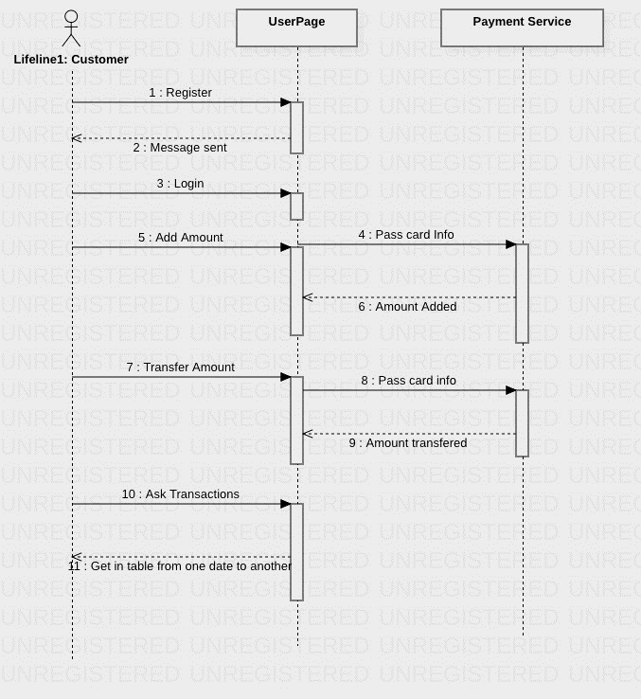

1. Admin activity diagram

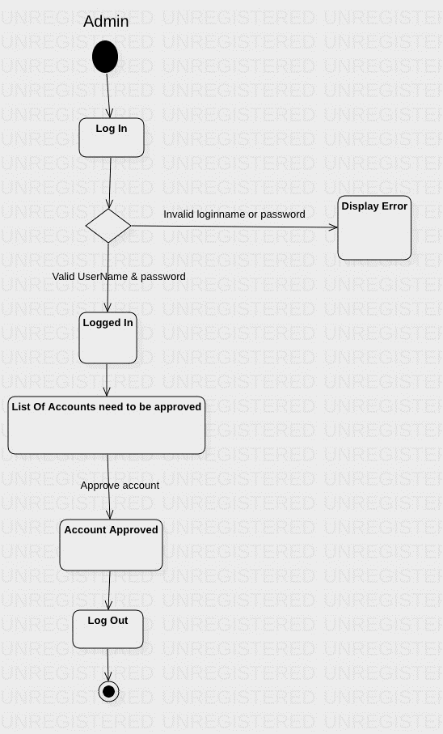

* **Use case diagram**

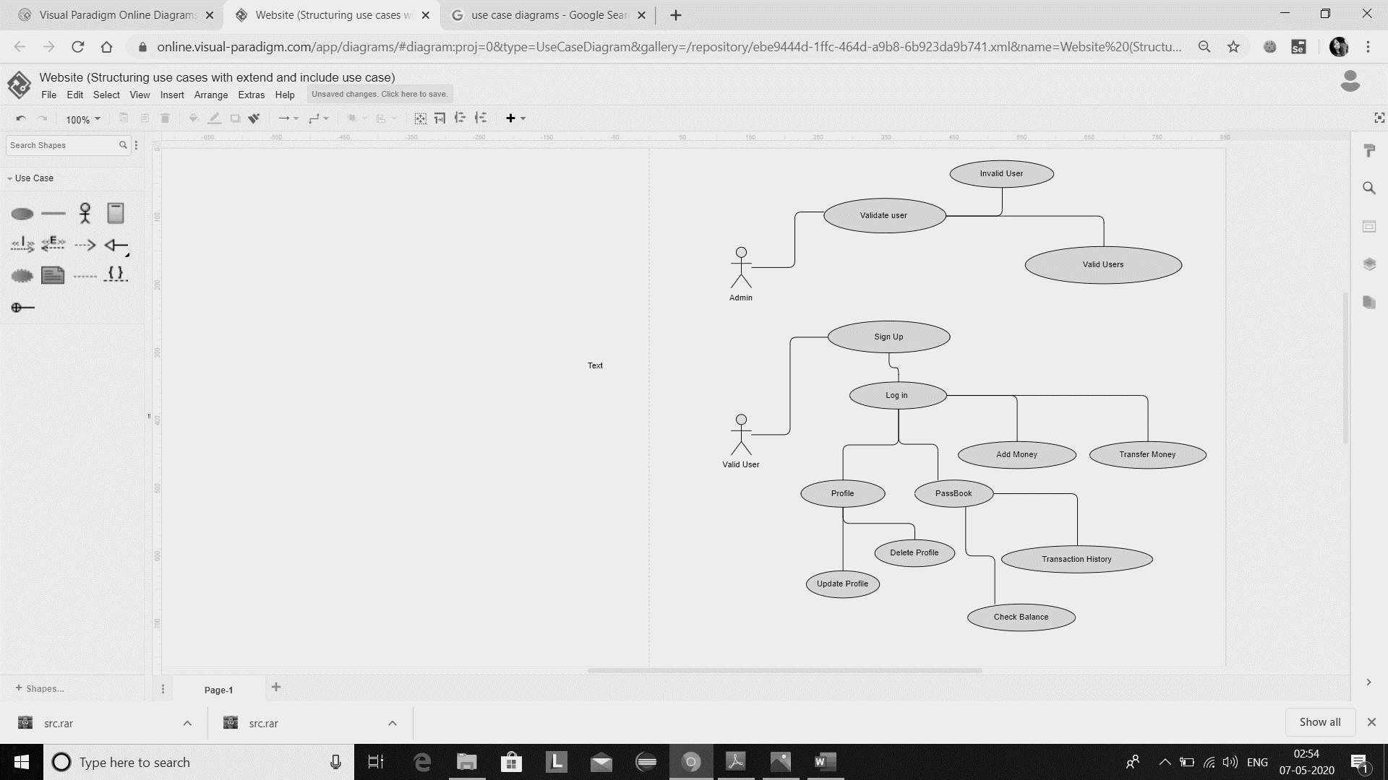

* Each Use Case Detail Description

1. **Admin**: Admin is responsible for validating the users. The users validated can log in into their account and use the functions of online wallet.
2. **User:** The users validated by admin are valid users.
3. **Sign up:** The valid users create their account in the wallet by signing up. They provide the details to sign up and same details are used by them later while logging in.
4. **Login:** Using login function any user who has already signed up can log in into their account and use online wallet as per their use.
5. **Profile:** When user is logged in there is a profile section in the wallet in which user can either update their already existing profile or delete it.
6. **Passbook:** In pass book any user can check their transaction history. They can even search their transaction filtering by date
7. **Check Balance:** A user can check his/her wallet balance anytime by using check balance. It reflects the amount in user’s wallet at any given time
8. **Add Money:** Wallet user can add a sum of amount (maximum of 10,000 rupee) at any time into their wallet using add Money option in wallet.
9. **Transfer Money:** A wallet user can transfer money to any other wallet user using their account IDs. Maximum of 10,000 per transaction is allowed.